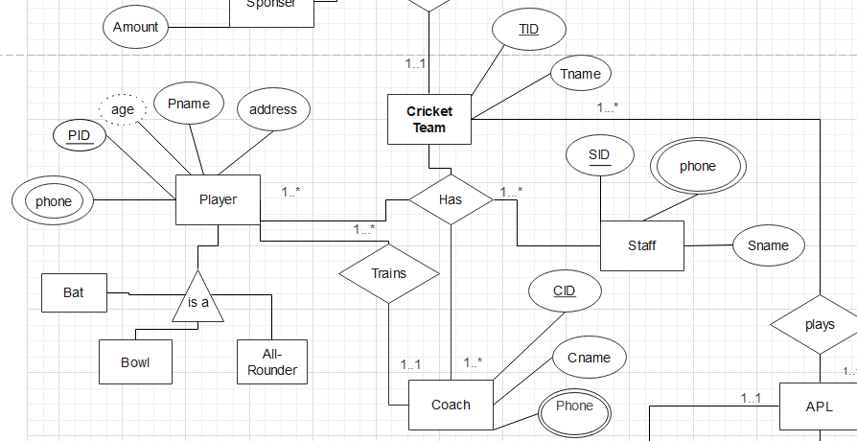   
  
Has Relation:  
 **UNF:**TID , Tname , PID ,Pname , age , phone , address , CID , Cname , phone , SID , Sname , Phone  
  
**1NF:**

i)TID , Tname , PID ,Pname , age , phone , address , CID , Cname , phone , SID , Sname , Phone  
  
**2NF :**

i)TID , Tname

ii) PID ,Pname , age , phone , address , TID(FK)

iii)CID , Cname , phone , TID(FK)

iv) SID , Sname , Phone , TID(FK)

**3NF** will be same as **2NF**

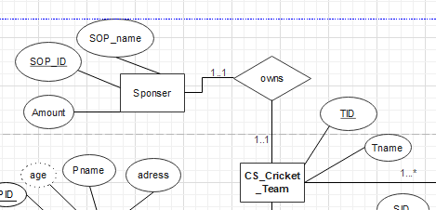

OWNS RELATION: **UNF:**

TID , Tname , SOP_ID , SOP_name , Amount   
  
**1NF:**   
i) TID , Tname , SOP_ID , SOP_name , Amount

**2NF:**i) TID , Tname

ii) SOP_ID , SOP_name , Amount  
iii) TID , SOP_ID(FK)

**3NF** will be same as **2NF**

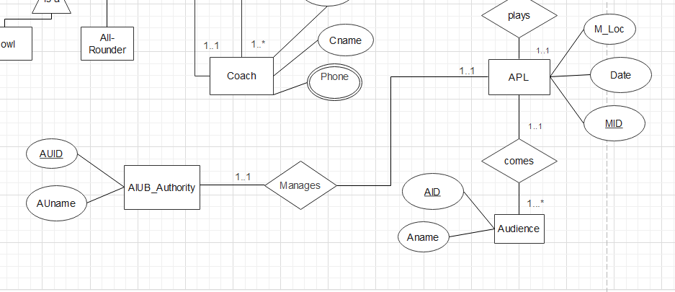MANAGES RELATION : **UNF:**

MID , M_Loc ,Date, AUID , AUname   
  
**1NF:**   
i) MID , M_Loc ,Date, AUID , AUname   
**2NF:**i) MID , M_Loc , Date

ii) AUID , AUname   
iii) MID , AUID(FK)

**3NF** will be same as **2NF**

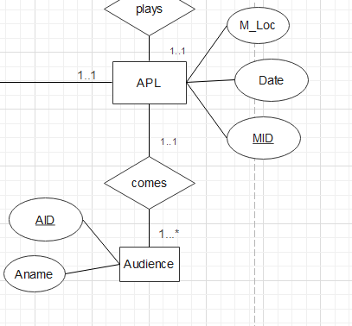

COMES RELATION:

**UNF:**

MID , M_Loc ,Date, AID , Aname   
  
**1NF:**   
i) MID , M_Loc ,Date, AID , Aname   
**2NF:**i) MID , M_Loc , Date

ii) AID , AUname , MID (FK)

**3NF** will be same as **2NF**

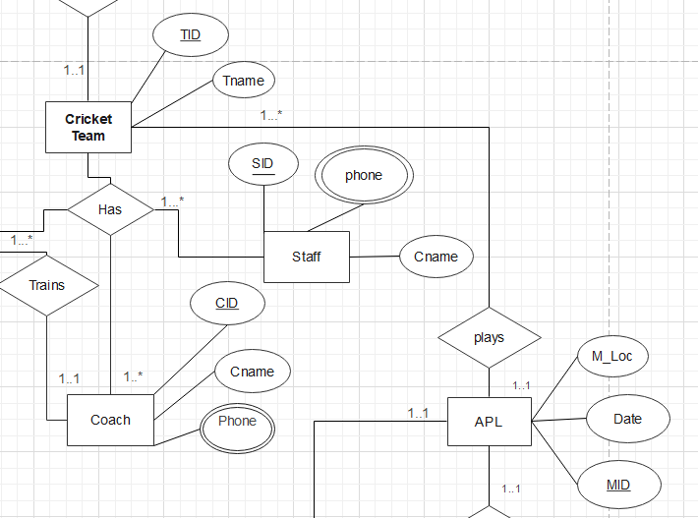

PLAYS RELATION : **UNF:**

MID , M_Loc ,Date, TID , Tname   
  
**1NF:**   
i) MID , M_Loc ,Date, TID , Tname   
**2NF:**i) MID , M_Loc , Date

ii) TID , Tname , MID (FK)

**3NF** will be same as **2NF**

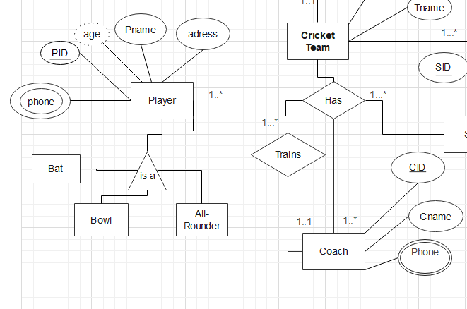

Trains Relation:

**UNF:** PID ,Pname , age , phone , address , CID , Cname , phone  
  
**1NF:**

i) PID ,Pname, age , phone , address , CID , Cname , phone  
  
**2NF :**

i) PID ,Pname , age , phone , address , CID(FK)

ii)CID , Cname , phone

**3NF** will be same as **2NF**

**Finalization :**i)TID , Tname

ii) PID ,Pname , age , phone , address , TID(FK)

iii)CID , Cname , phone , TID(FK)

iv) SID , Sname , Phone , TID(FK)

v) SOP_ID , SOP_name , Amount  
vi) TID , SOP_ID(FK)  
vii) MID , M_Loc , Date

viii) AUID , AUname

ix) MID , AUID(FK)

x) TID , Tname , MID (FK)  
xi) PID ,Pname , age , phone , address , CID(FK)

xii)CID , Cname , phone